Project name: Alleviating the instability of Stable Diffusion animation by controlling animation frames

Document name: Implementation plan for controlling animation frames through Lora and ControlNet to stabilize Stable Diffusion to generate animations

Author: Sun Haoran

Date: 2024/05/16

Table of contents

1. Introduction
2. System Overview
3. system structure
4. technical details
5. Case
6. appendix
7. Introduction
8. Purpose:

Starting from the essence of animation, by controlling each frame of AI animation, we can solve/ease the stability direction of current AI animation, and provide some inspiration and thinking.

1. Reader target:

AI animation creators, AI technology developers, and everyone interested in AI or animation

1. System Overview
2. System principle overview:

Split the video to be converted into frames one by one, import each frame one by one into the Stable Diffusion graph, and use the preset prompt words, ControlNet, and Lora to create each new animation generated after the frame is imported. Frame stability is controlled. By controlling the smallest unit frame of animation, control of the entire animation composed of frames is finally achieved.

1. Major premise:

Lora’s painting style should be consistent with that of the large model

1. system structure
2. Process control main diagram:



1. Prompt word generation diagram:



1. ControlNet uses:



1. technical details
2. The frames of the original video must be consistent: the frames put into ControlNet and the frames used to generate the prompt words must be consistent with the frames used to generate the prompt words (the frames used to generate the prompt words only need to be representative frames of the same scene, and the generated prompts words, the same scene frame can be used continuously when drawing pictures)
3. The frames of the original video are imported into ChatGPT. The elements contained in the imported image are first analyzed and then converted into prompt words that Stable Diffusion can understand.
4. In order to obtain a more stable effect, Lora and the base model/large model in the same painting style need to be trained separately. The long shot, medium shot, and close shot of Lora are selected according to the scene of the original video frame.
5. A set of keywords corresponds to a set of original video frames. The same goes for Lora.
6. Case 1 (a set of shots)

Original video frame:

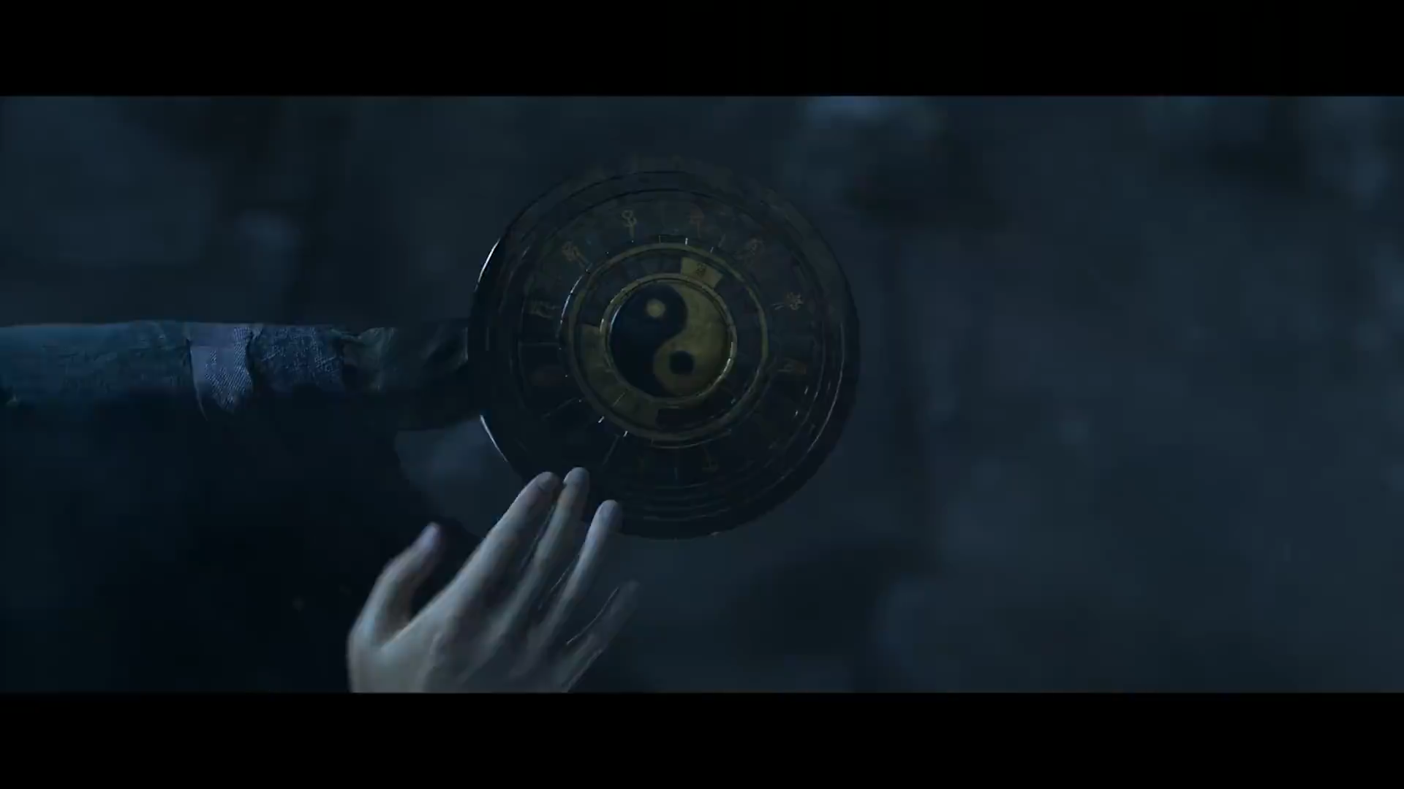

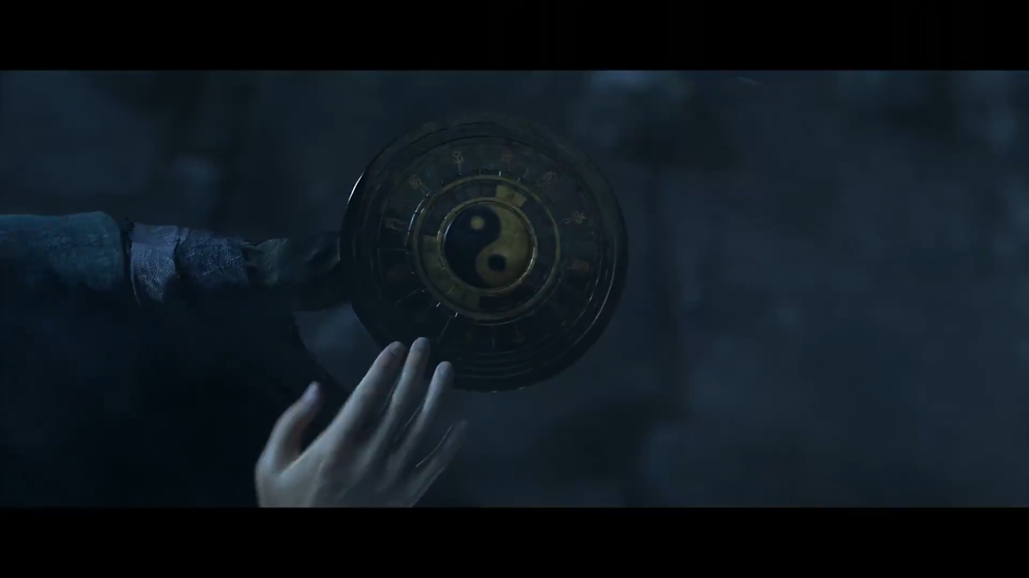

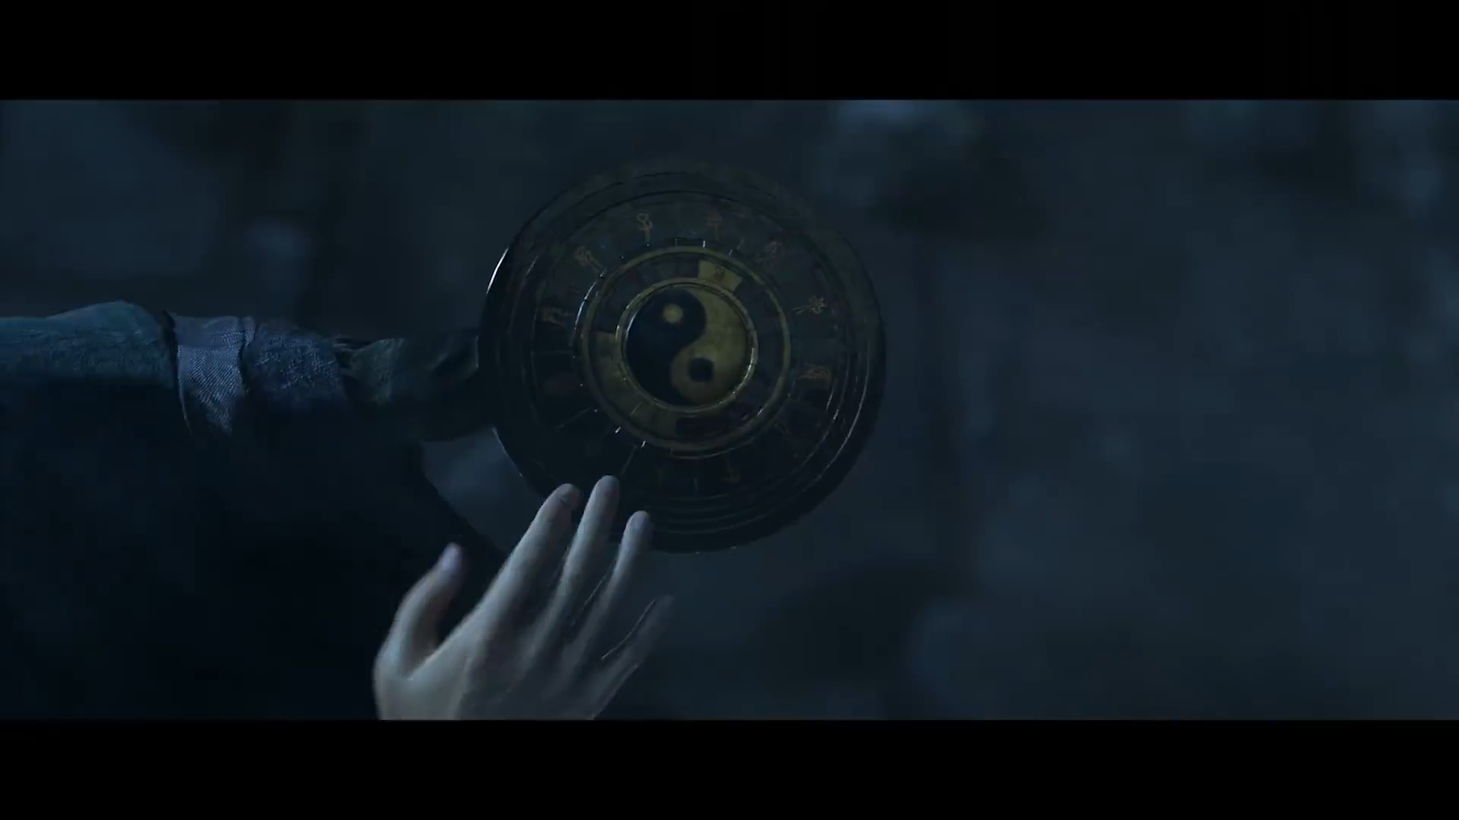

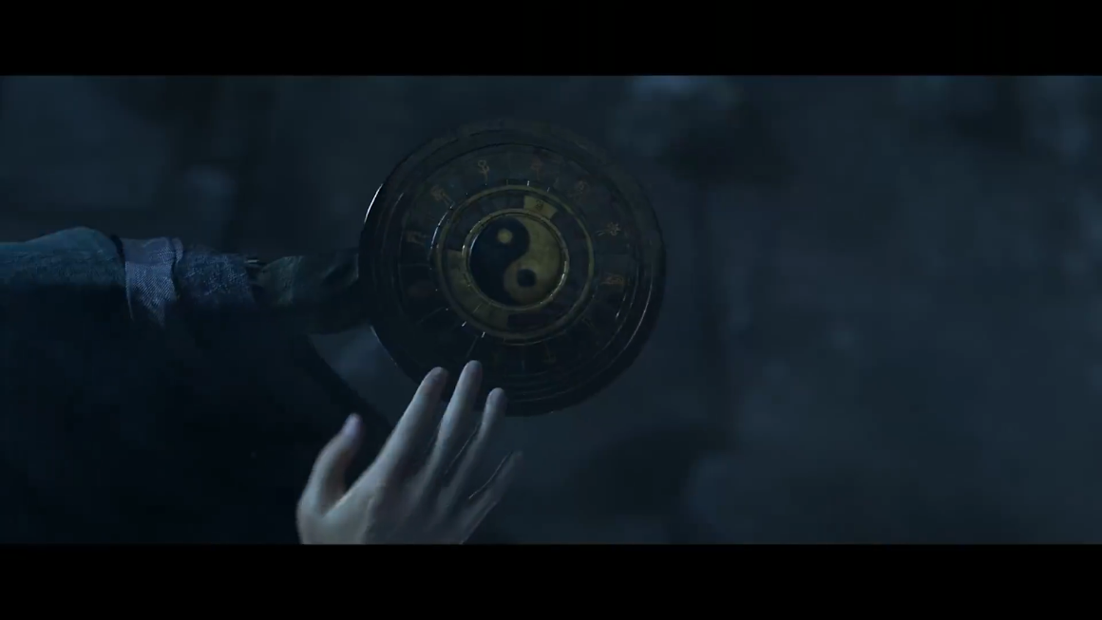

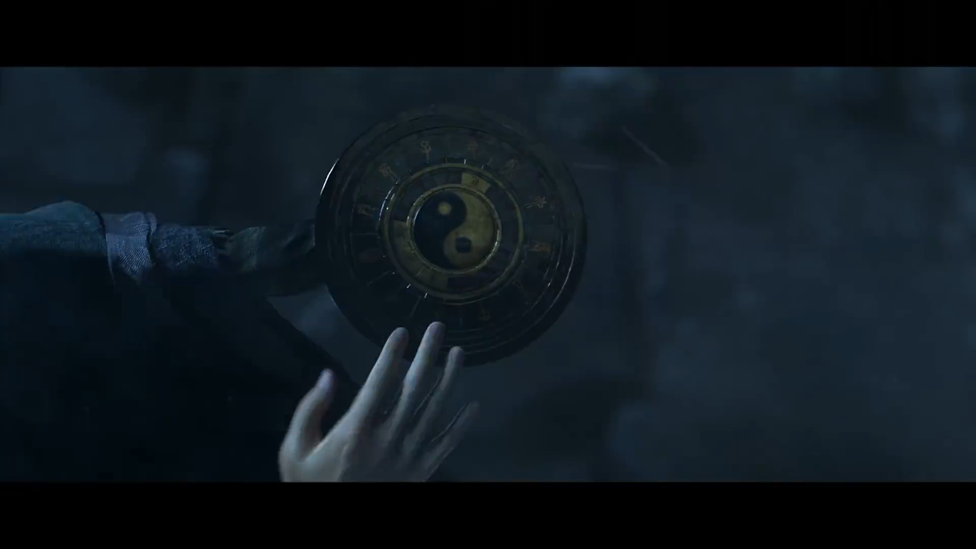

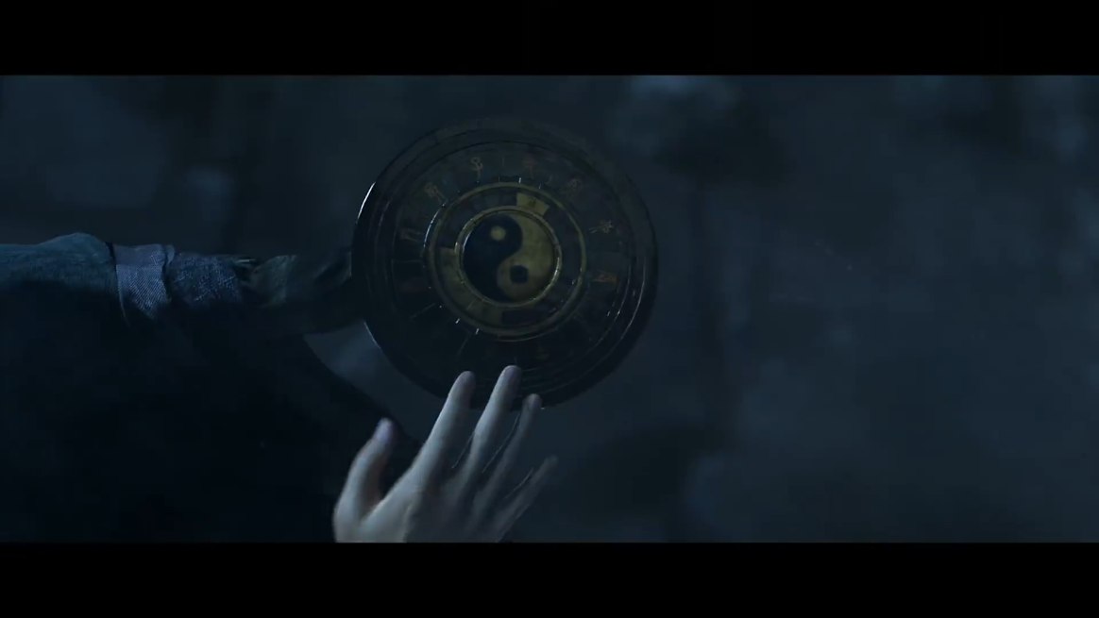

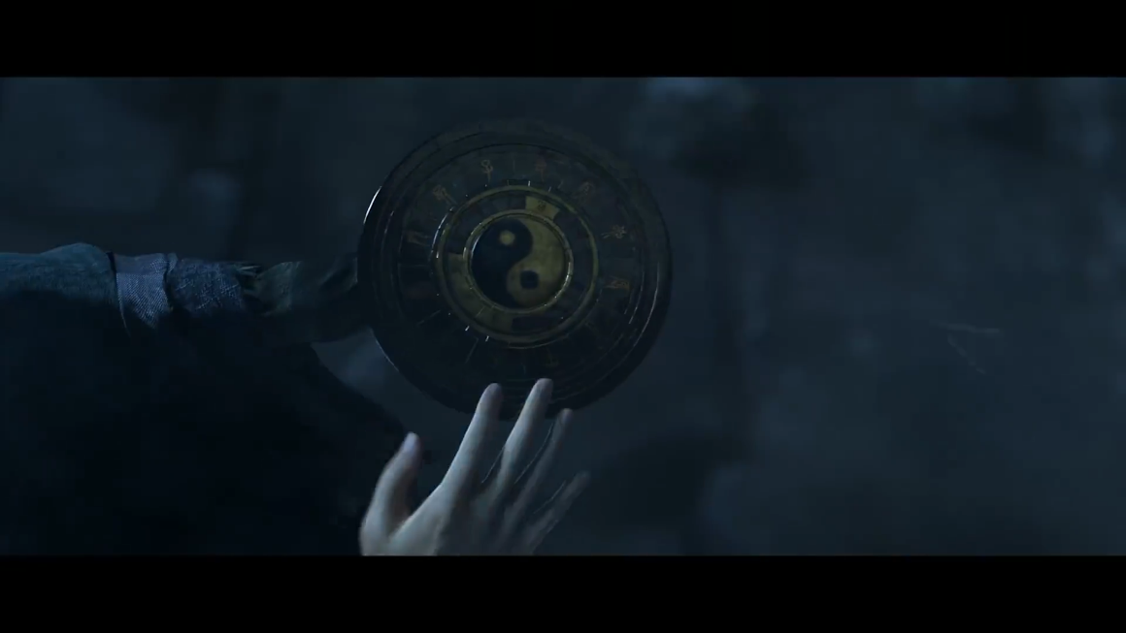

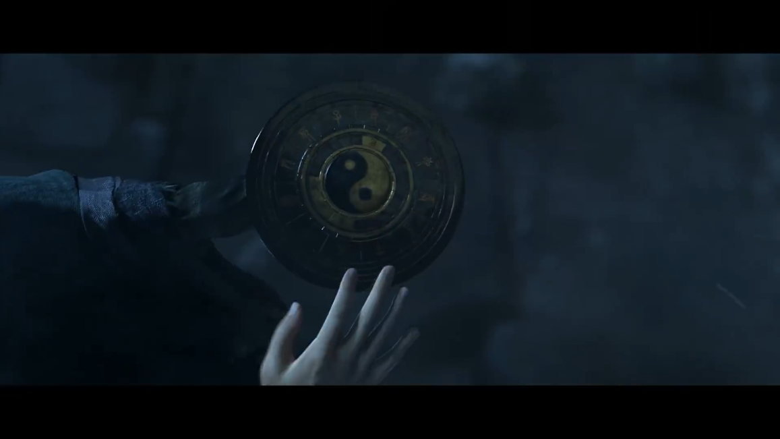

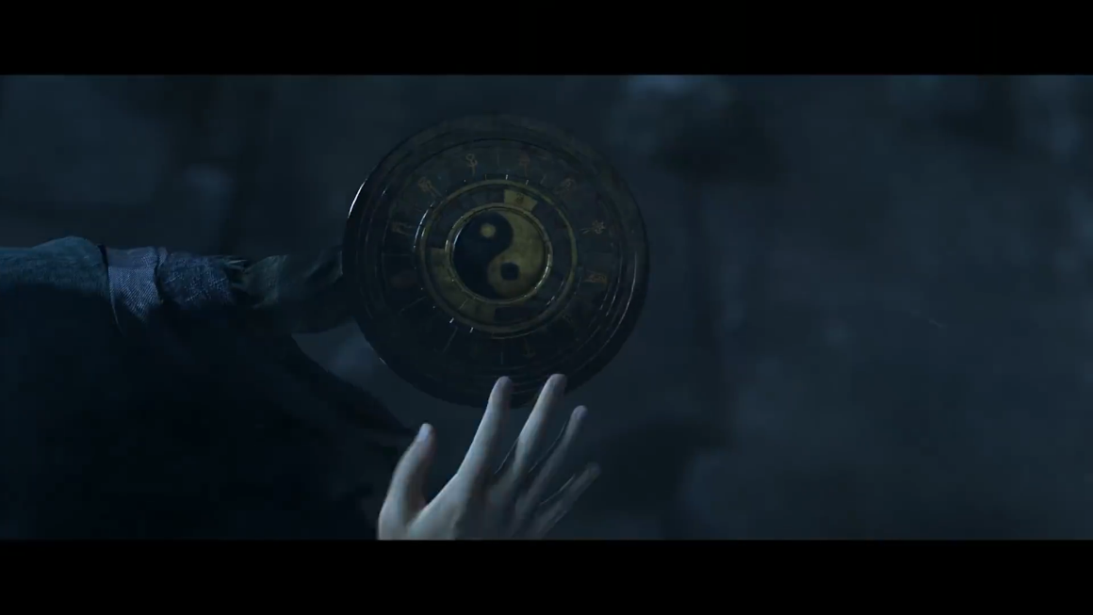

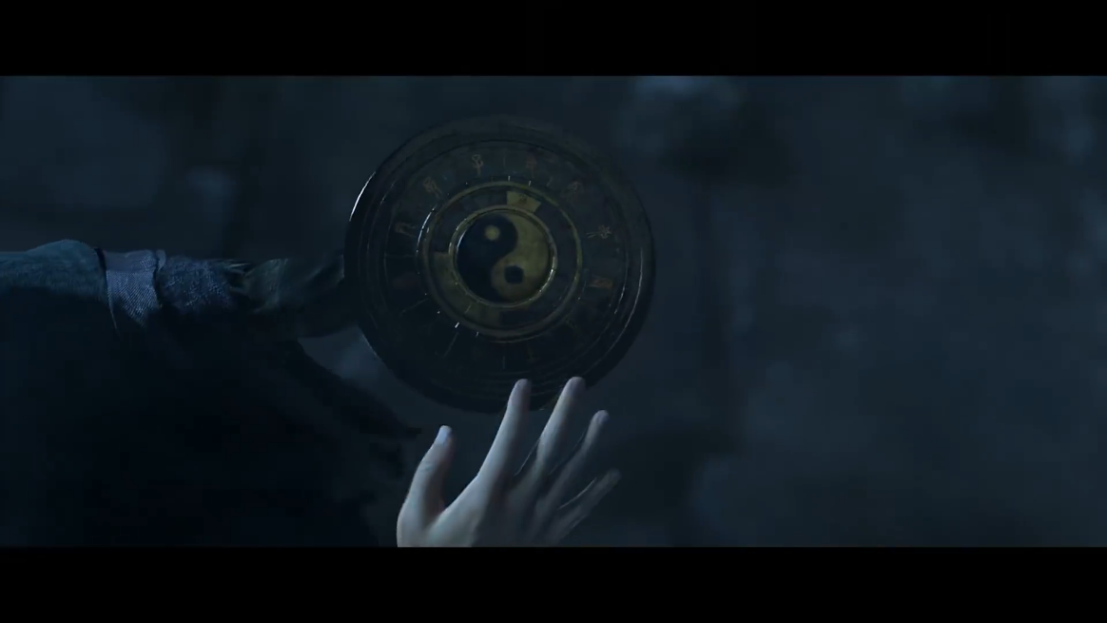

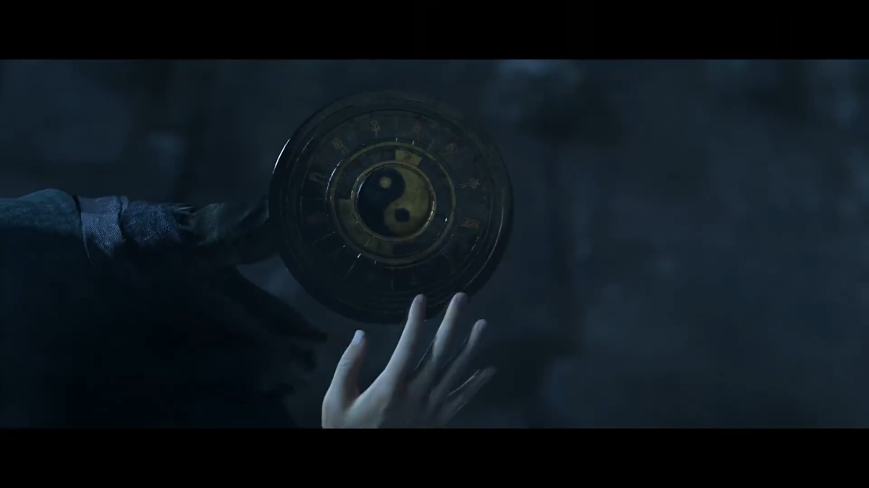

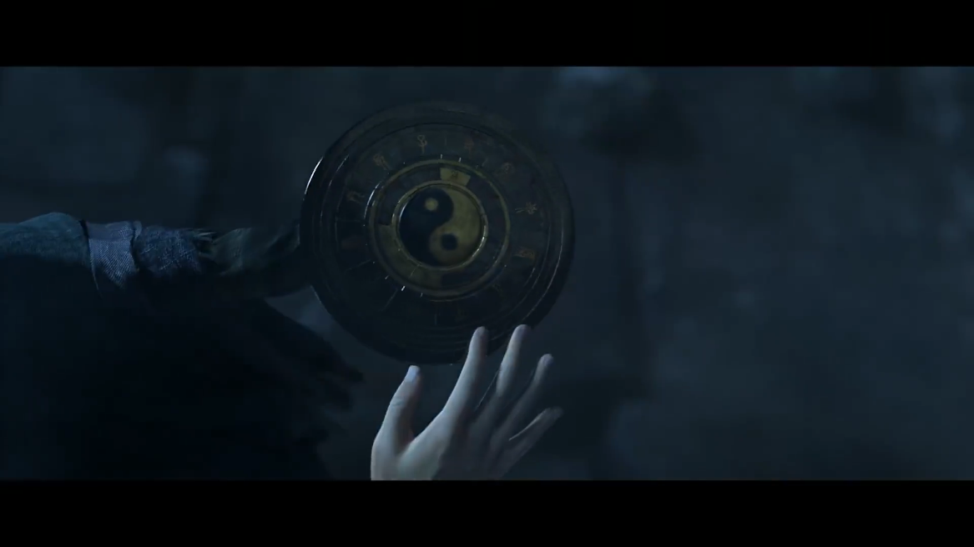

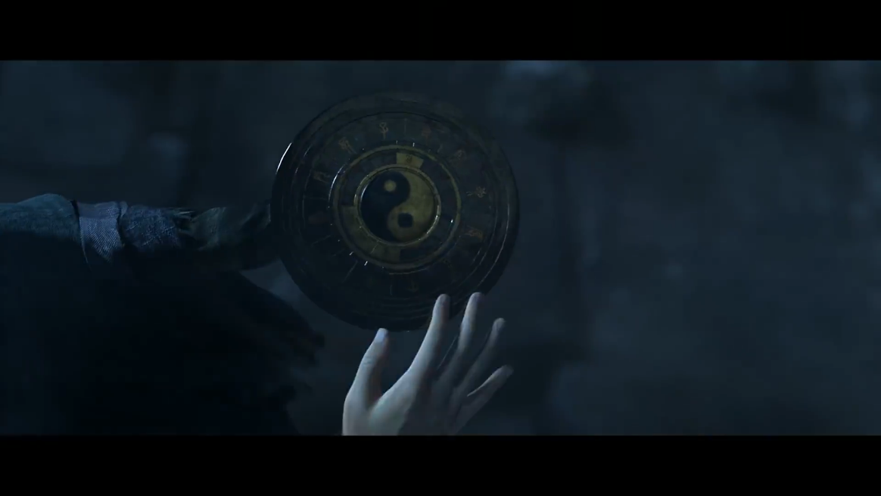

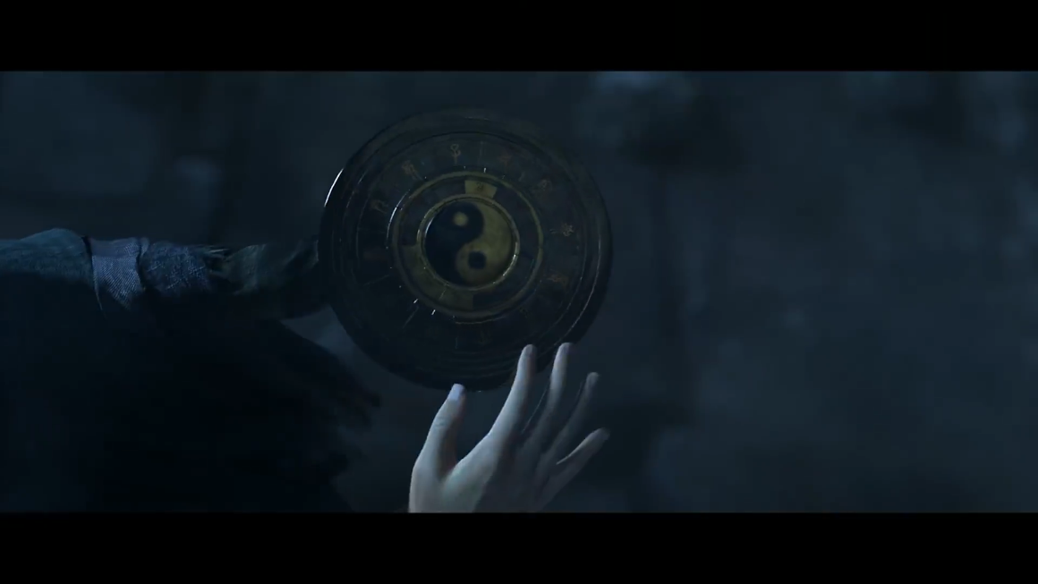

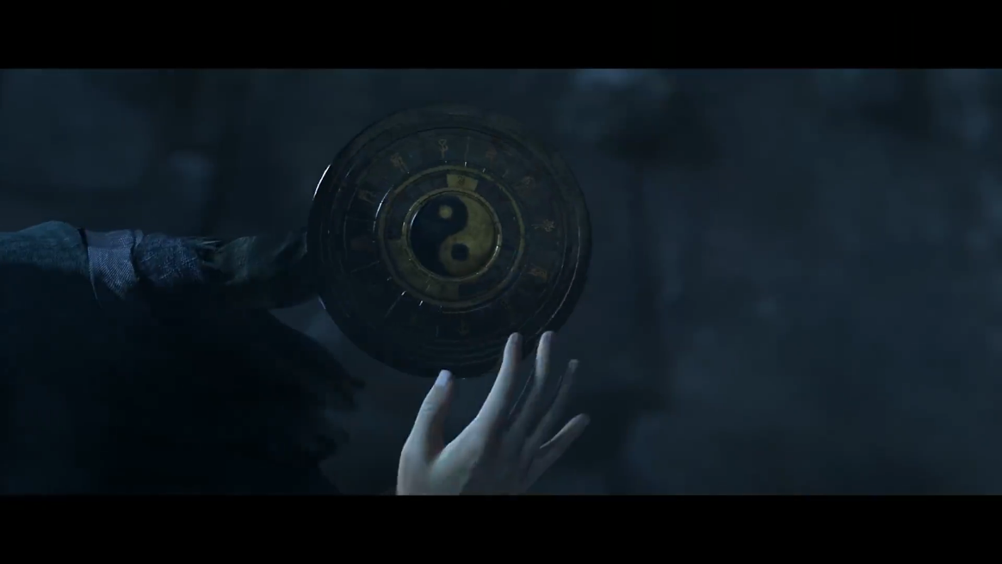

Stable Diffusion corresponding conversion screen:

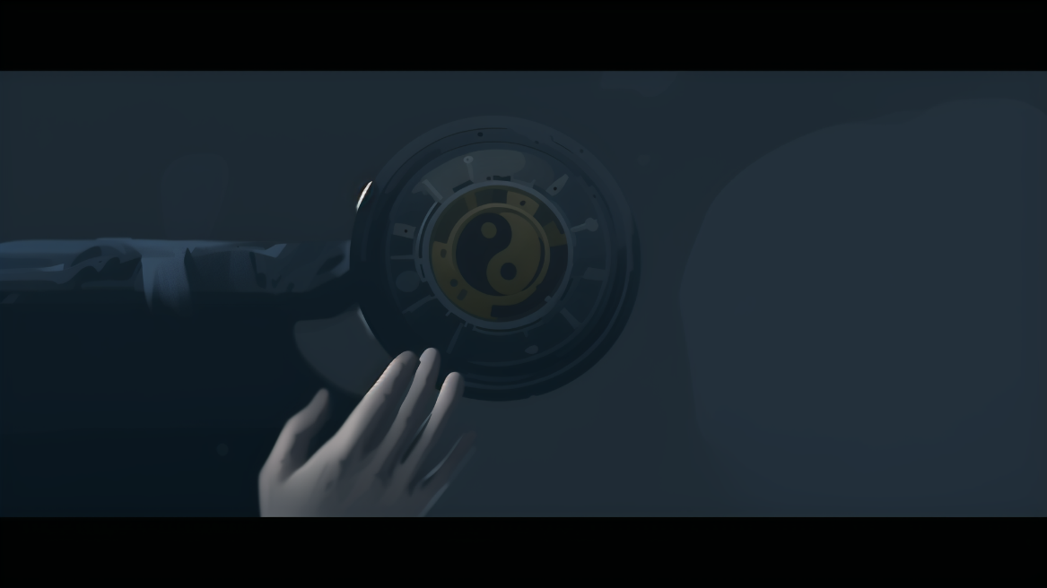

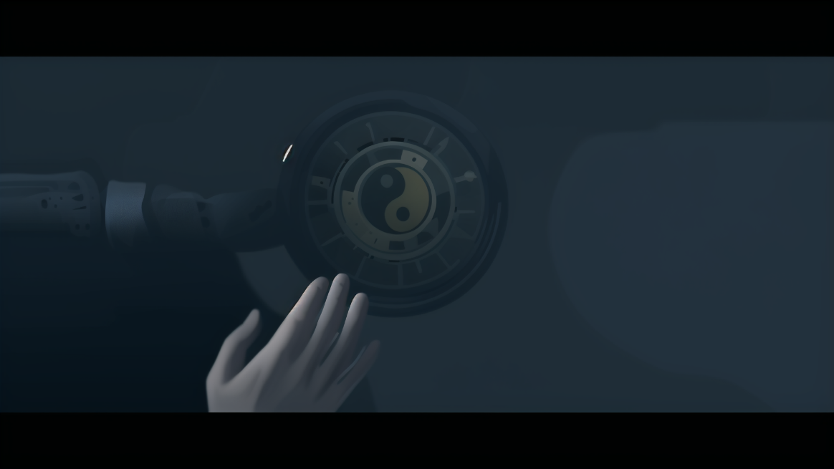

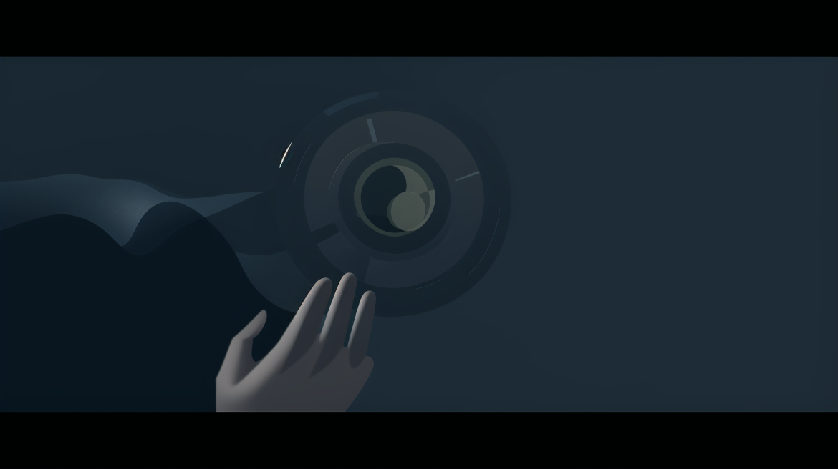

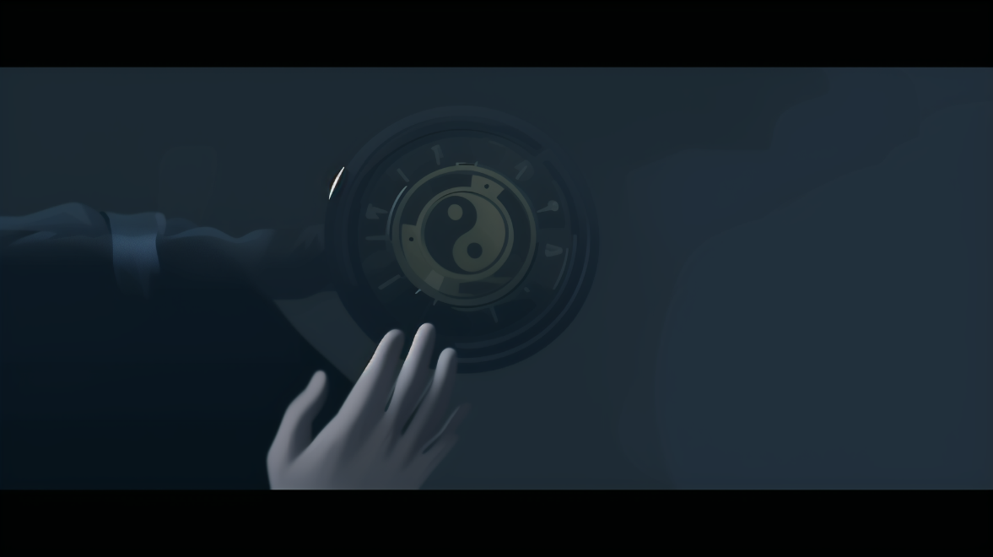

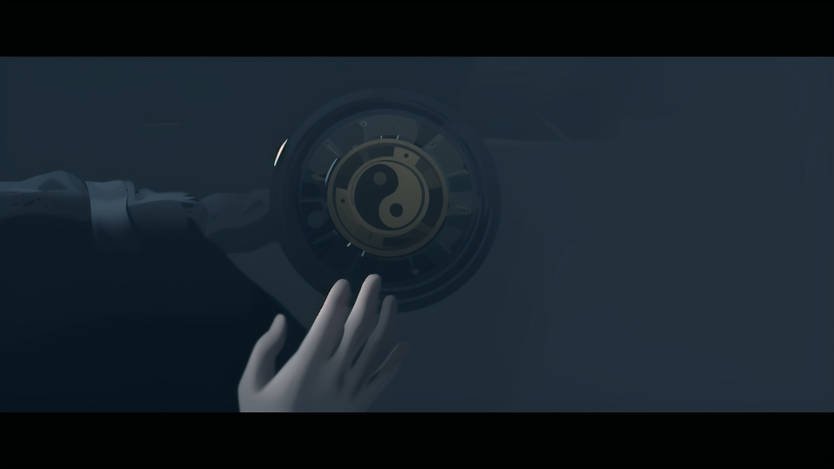

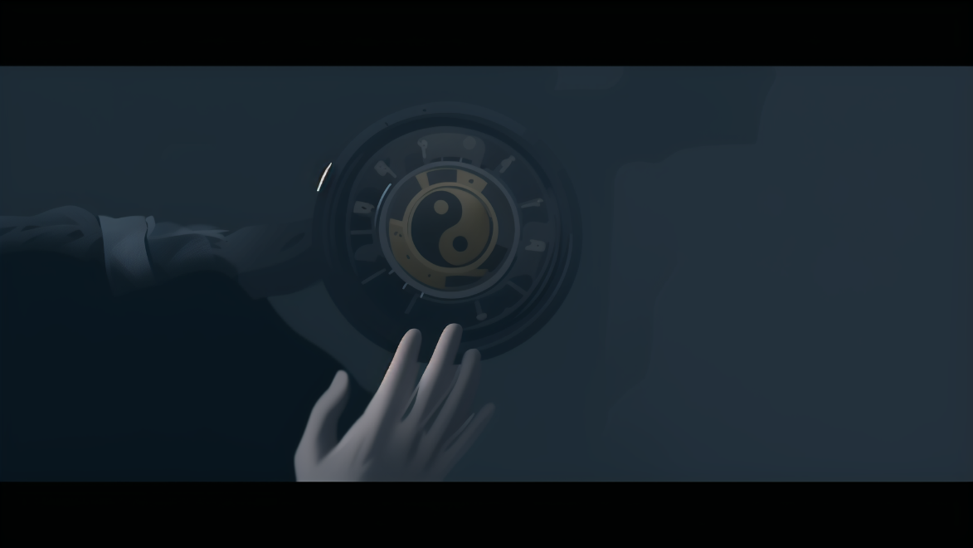

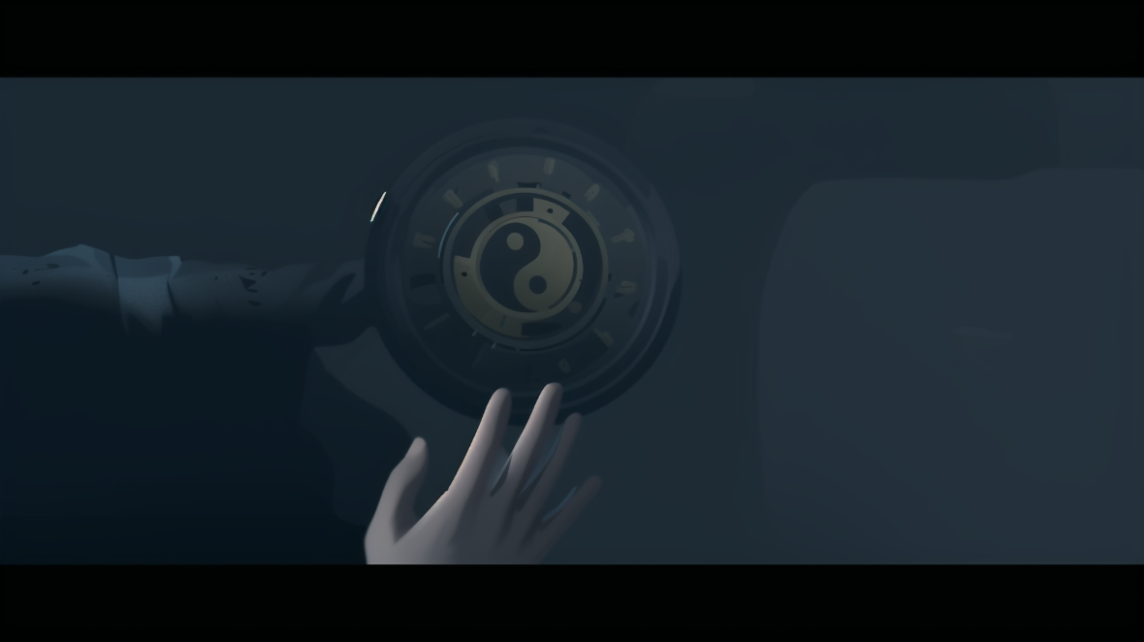



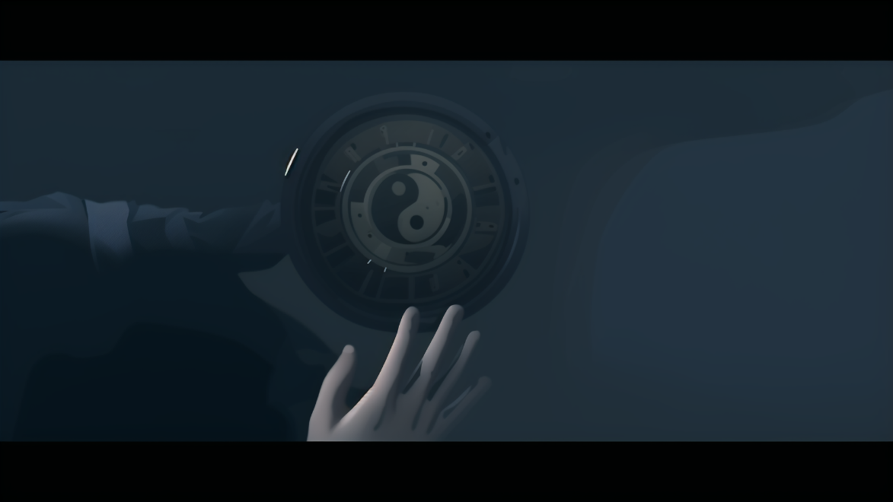

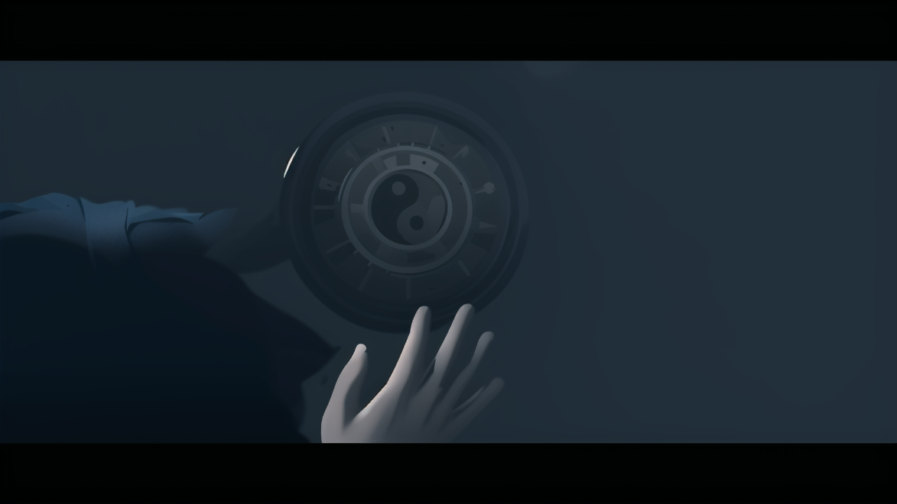

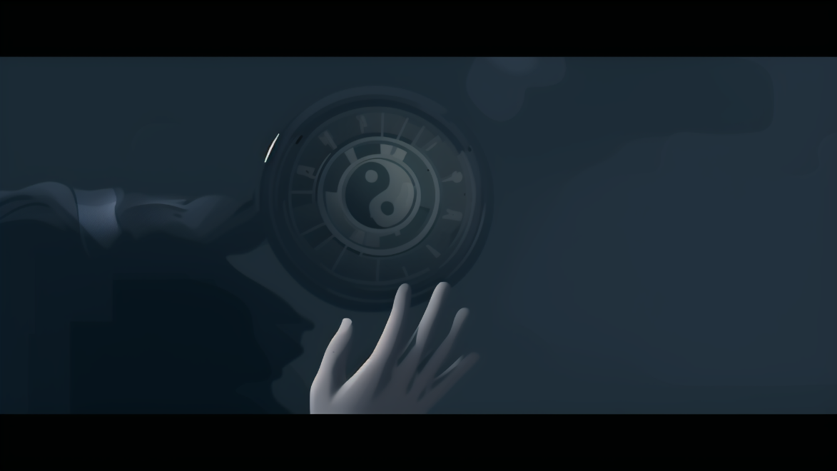

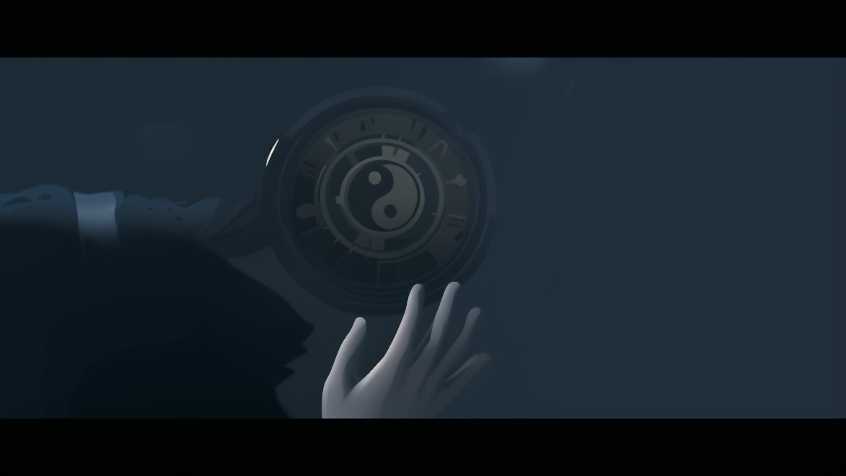

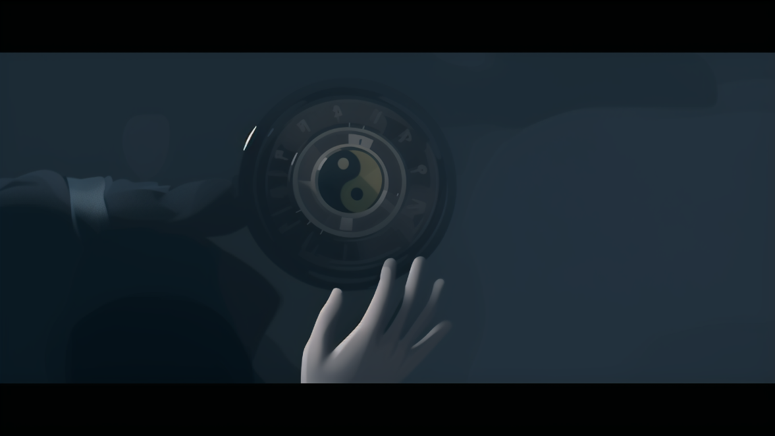

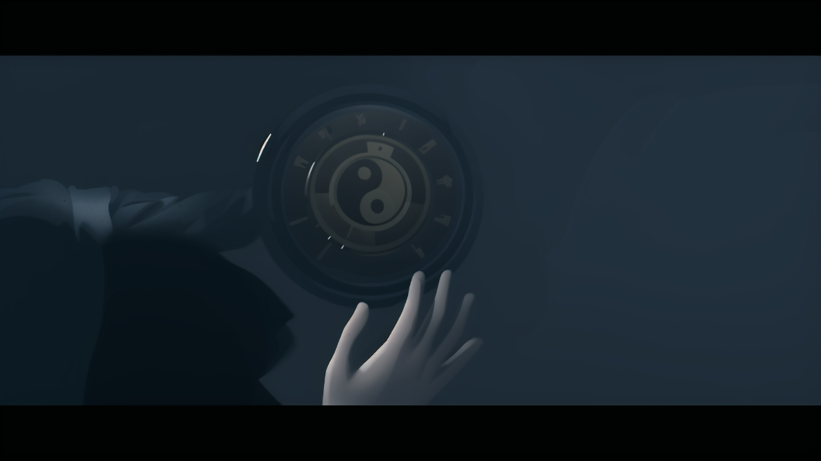

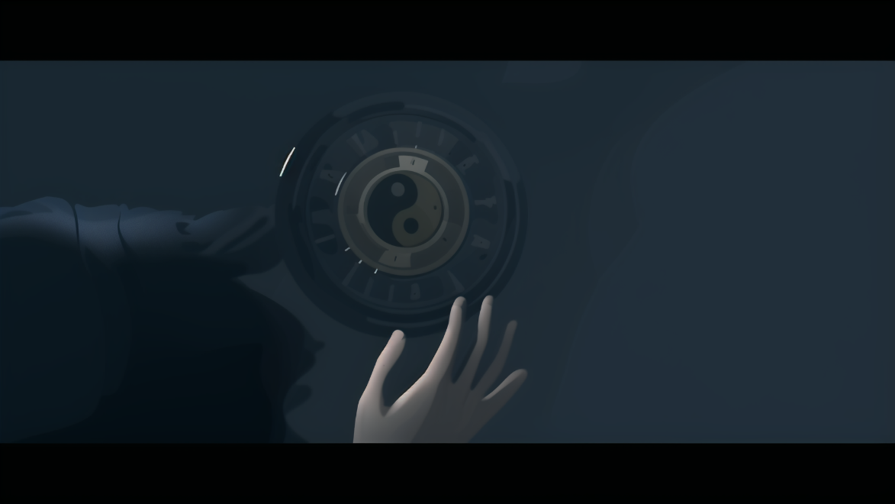

Prompt:

high quality,masterpiece,best quality,ultra highres,ultra-detailed,fantastic,closeup photo,

Negative prompt:

embedding:EasyNegativeV2,embedding:ng_deepnegative_v1_75t,embedding:badhandv4, Easy Negative,worst quality,low quality,normal quality,lowers,monochrome,grayscales,skin spots,acnes,skin blemishes,age spot,6 more fingers on one hand,deformity, bad legs,error legs,bad feet,malformed limbs,extra limbs,ugly,poorly drawn hands,poorly drawn feet,poorly drawn face,text,mutilated,extra fingers,mutated hands,mutation,bad anatomy,cloned face,disfigured,fused fingers, blurry,malformed,distorted,naked,

Sampler:

Euler a

Model:

flat simple color flatanime-mix

Lora: Simple flat illustration丨CJ_illustration

Correlation (CFG scale):

8

Redraw range:

0.4

Number of steps:

40

Pixel size:

1920*1080

ControlNet:

Control Type:

Lineart

1. appendix

Model author:



Model address:

<https://www.liblib.art/modelinfo/4bc78379d7024c83a7f60deb364bd2b6>

Lora Author:

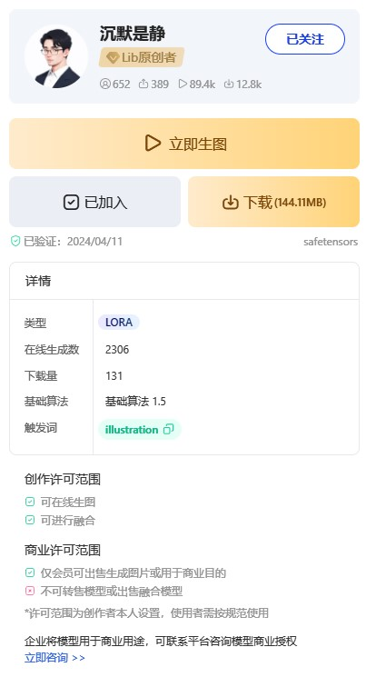

Lora address:

<https://www.liblib.art/modelinfo/39ca2741bce043c7a012d5fbc2d7bb0e>

Case material:

"Three-Body" TV series

address:

<https://v.qq.com/x/cover/mzc002007knmh3g/i0045u918s5.html>

If you quote this document, please indicate the source.